Transitional Kindergarten
Supply List

*The items listed below are for the use of your child only. We will not be sharing classroom supplies.

- 1 ½ inch binder
- 1 box of Crayola crayons (24 count)
- 1 pack of Crayola markers
- 1 set of Crayola watercolor paints
- 2 pack of “My First” Ticonderoga pencils
- 4 Expo Dry-Erase markers (any color)
- 4 Elmer’s glue sticks
- 1 bag of dried beans
- 1 bag of rice
- 1 box of kleenx
- 1 container of clorox wipes
- 1 six-quart storage container with latches (this will prevent many spills)
- 2 bottles of hand soap

Optional and greatly appreciated:
- Bingo dotters
- kwik stix (found on Amazon)
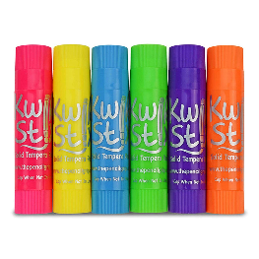

*Specific name brands have been suggested because of their quality and durability.

Your child will need the following personal items at school:
- Sturdy backpack (large enough to fit a folder, library book, and lunch bag)
- Lunch bag: Please label with your child’s first and last name.
- Personal snack bags- One bag will be for AM snack and the other bag for a PM snack.
- Complete extra set of clothes: Please place in a bag labeled with your child’s name.

Rochester Community Schools must provide all necessary materials and supplies for curricular classes. Parents who wish to supplement these materials and supplies for their student may consider purchasing the items listed above.

